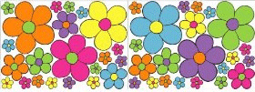Sample Song List

Day Dream Believer
San Francisco
Henry the 8th
Both Sides Now
Shoop Shoop
In My Life
California Dreamin'
Everyday People
Piece of My Heart
Light My Fire
Aquarius

