Jackie Wilson, “The Legacy” starring Bobby Wilson

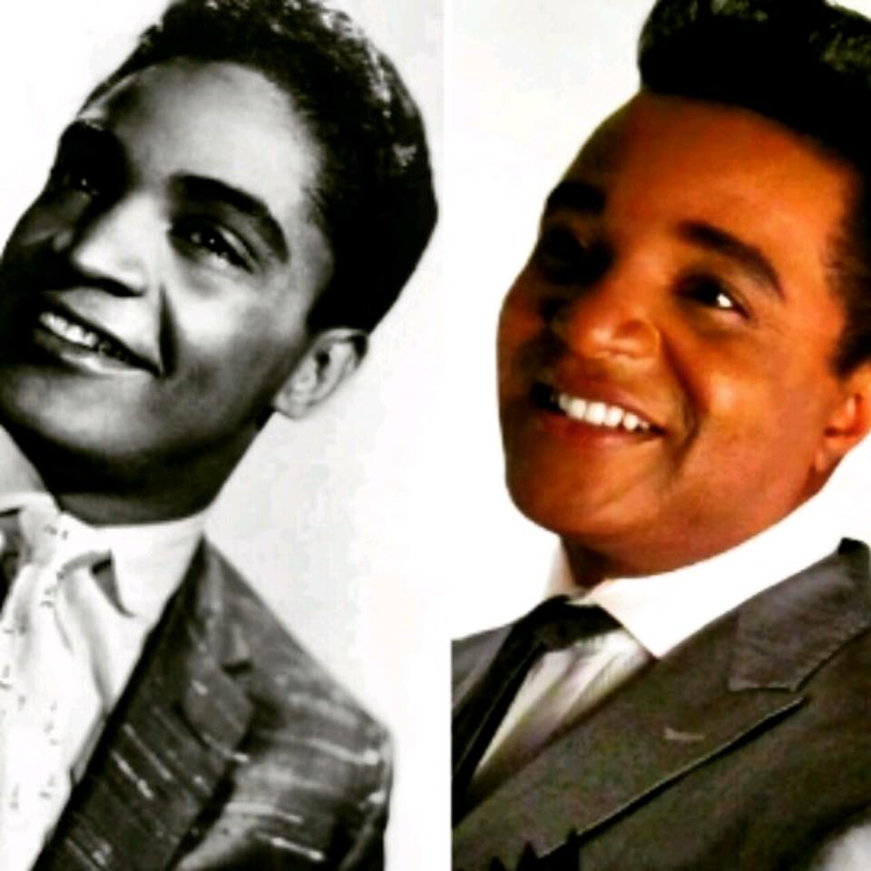

***“Jackie Wilson the Legacy”*** is a show about a son continuing the musical tradition set forth by his father, Legendary Soul R&B Artist Jackie Wilson and a continuation of that style of Soul music that began in the year of 1959!

Imagine a hot summer night in Harlem New York, Theater, the music was new and no one could stop there body’s from swaying or feet from taping. A debonair young man in a sharp dressed shark skin tailored suit with diamond cuff links, slides to the mic stand and hit his first note of the newest hit song “Lonely Teadrops”, but wait, it’s not 1959 but today and the man isn’t Jackie Wilson, but his **son Bobby Wilson.**

One has to pinch themselves because of the **“IT”** factor, this song and dance man apparently inherit from his Legendary Father. He has the moves, the swagger, and the audience in the palm of his hands as his movement through the years of Motown music and beyond air lifts the event **“Higher and Higher”** Plateau! Not only is his father Motown Royalty but his father first cousin **Levi Stubbs** **and Lawrence Patton of “ The Four Tops”** all grew up in the same hood not to mention the penmanship of his songs by **Berry Gordy Jr and T. Carlo** which happens to be a cousin too.

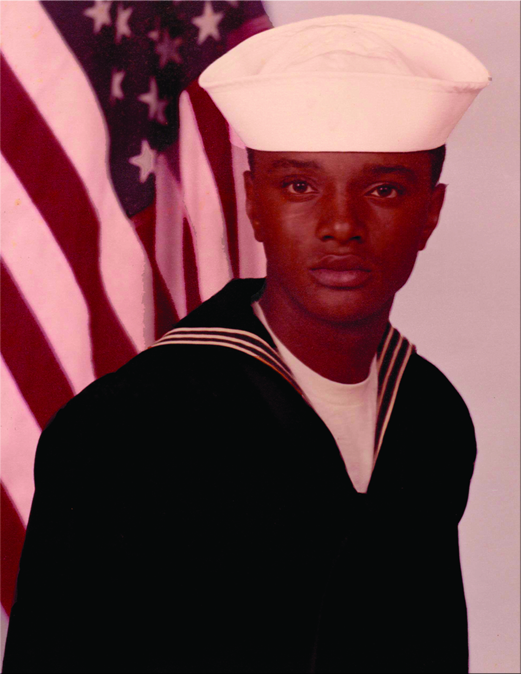

Bobby wasn’t handed this business with a silver spoon but instead he was doing a tribute to The R&B Hit maker, long before he ever knew he was related. His career began in the US Navy, before a medical discharge and singing in a karaoke bar when ***Peter Hernandez, father of Pop Star Bruno Mars***, spotted Bobby and hired him to be on his **“Lovenotes Doo Wop Show”** in Waikiki. That’s when the bells and whistles went off for BW and he was never the same again.

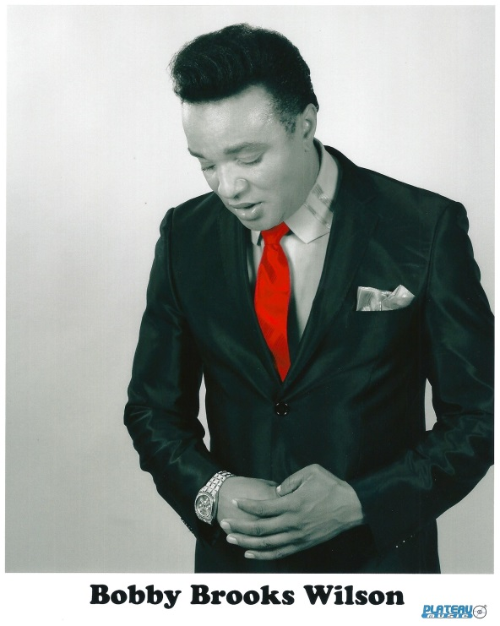

As of today, Bobby has landed on **the 2014 and 2015 Ballot of the Grammys** for 2 of the 4 singles released to **radio that all peaked #10 on the Adult Contemporary Charts**, via his current CD Entitled ***“It’s About Time”!*** He is touring all over the world on Cruise Ships, Theaters, Rockabilly Shows, Car Shows, Corp Shows and private events and if that’s not enough, he is in the middle of his auto-bio-pic for book and or movie consideration for those who at this time must remain nameless. A much anticipated untitled work in progress while he continues to promote his CD and Shows around the Globe.

This is a must have musical in your event, venue, festival or convention and will take your cliental to a whole new world.

